Assignment 1

Secure Programming

B00159127 Lan Ngai, B00159763 Kai Guy

Contents

Path Traversal & Arbitrary File Read 2

Remediation 2

Authentication Bypass 4

SQL Injection 5

IDOR 6

Stored XSS 7

Credential Leaking 8

Shoulder Surfing 9

Remediation 9

Resource Exhaustion 11

Statement of Contribution 12

Lan Ngai 12

Kai Guy 12

# Path Traversal & Arbitrary File Read

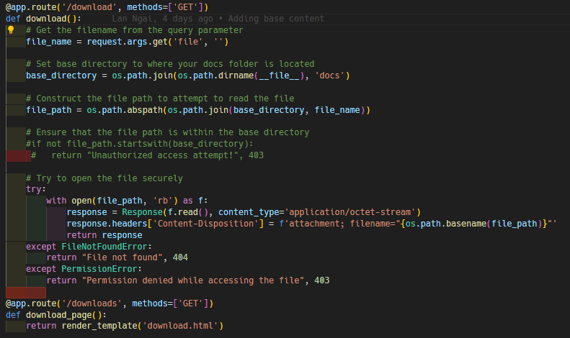

Figure - Source code Showcasing Vulnerability

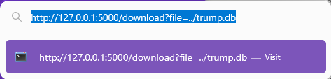

Figure - URL crafted to download the entire DB



Figure - Successful Download of Database

## Remediation

The simple fix to this **CRITICAL**vulnerability is surprisingly already in the source code, however it is commented out.

To repair the vulnerability, simply uncomment the code and you will no longer be able to traverse the directory structure beyond the “docs” folder.



Figure - Navigating to the same URL after applying the fix

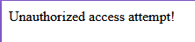

Figure - The Unauthorized access attempt properly displays

# Authentication Bypass

‘/admin_panel’ shown in requests when clicking on the sitemap option on the website. That’s how that page was made known to us.

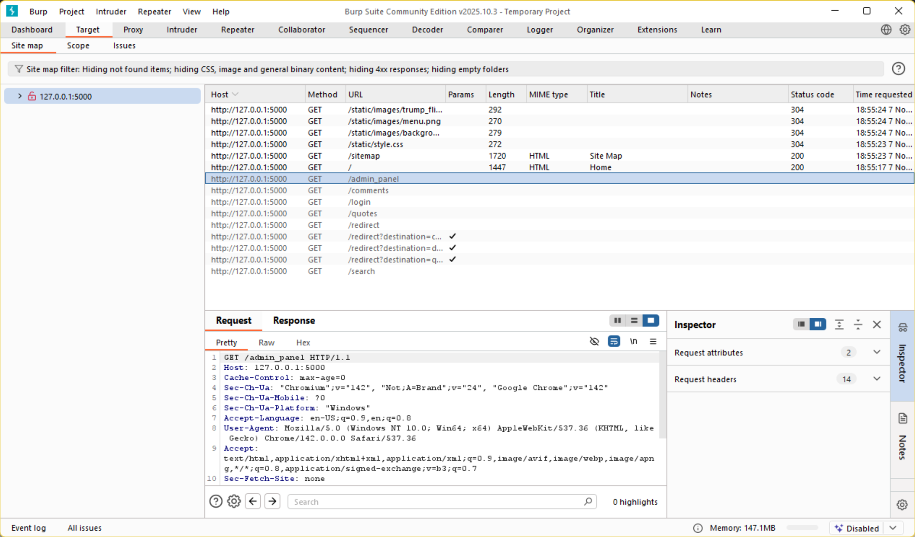

Adding ‘/admin_panel’ we get access to that page which is visible without logging in.

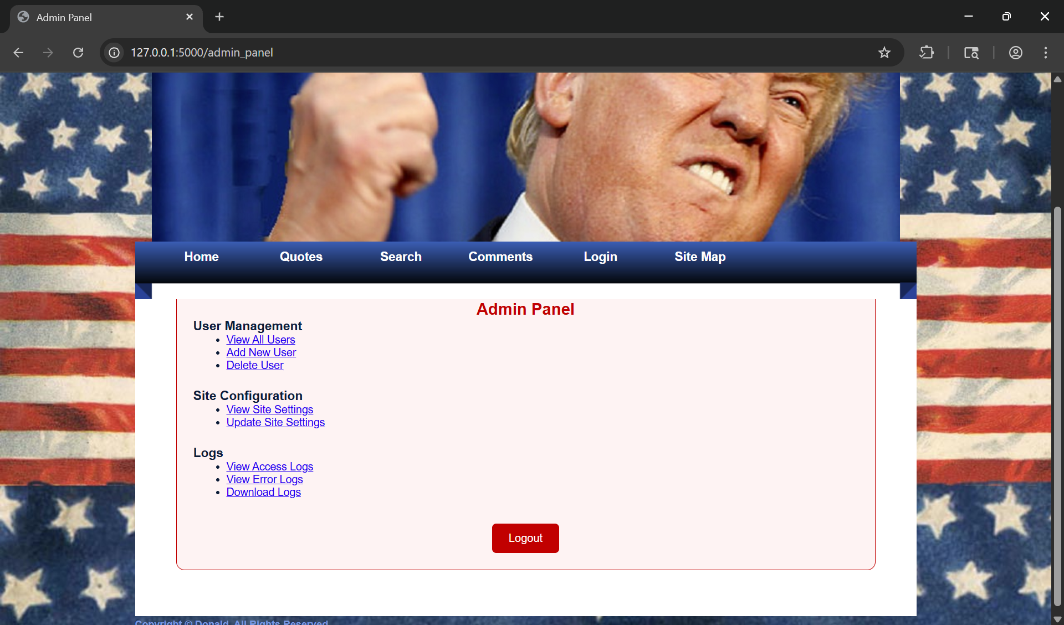

# SQL Injection

In the login page by putting the following (‘OR 1=1 --) in both the username and password fields logs you in due to that being a statement which is always true.

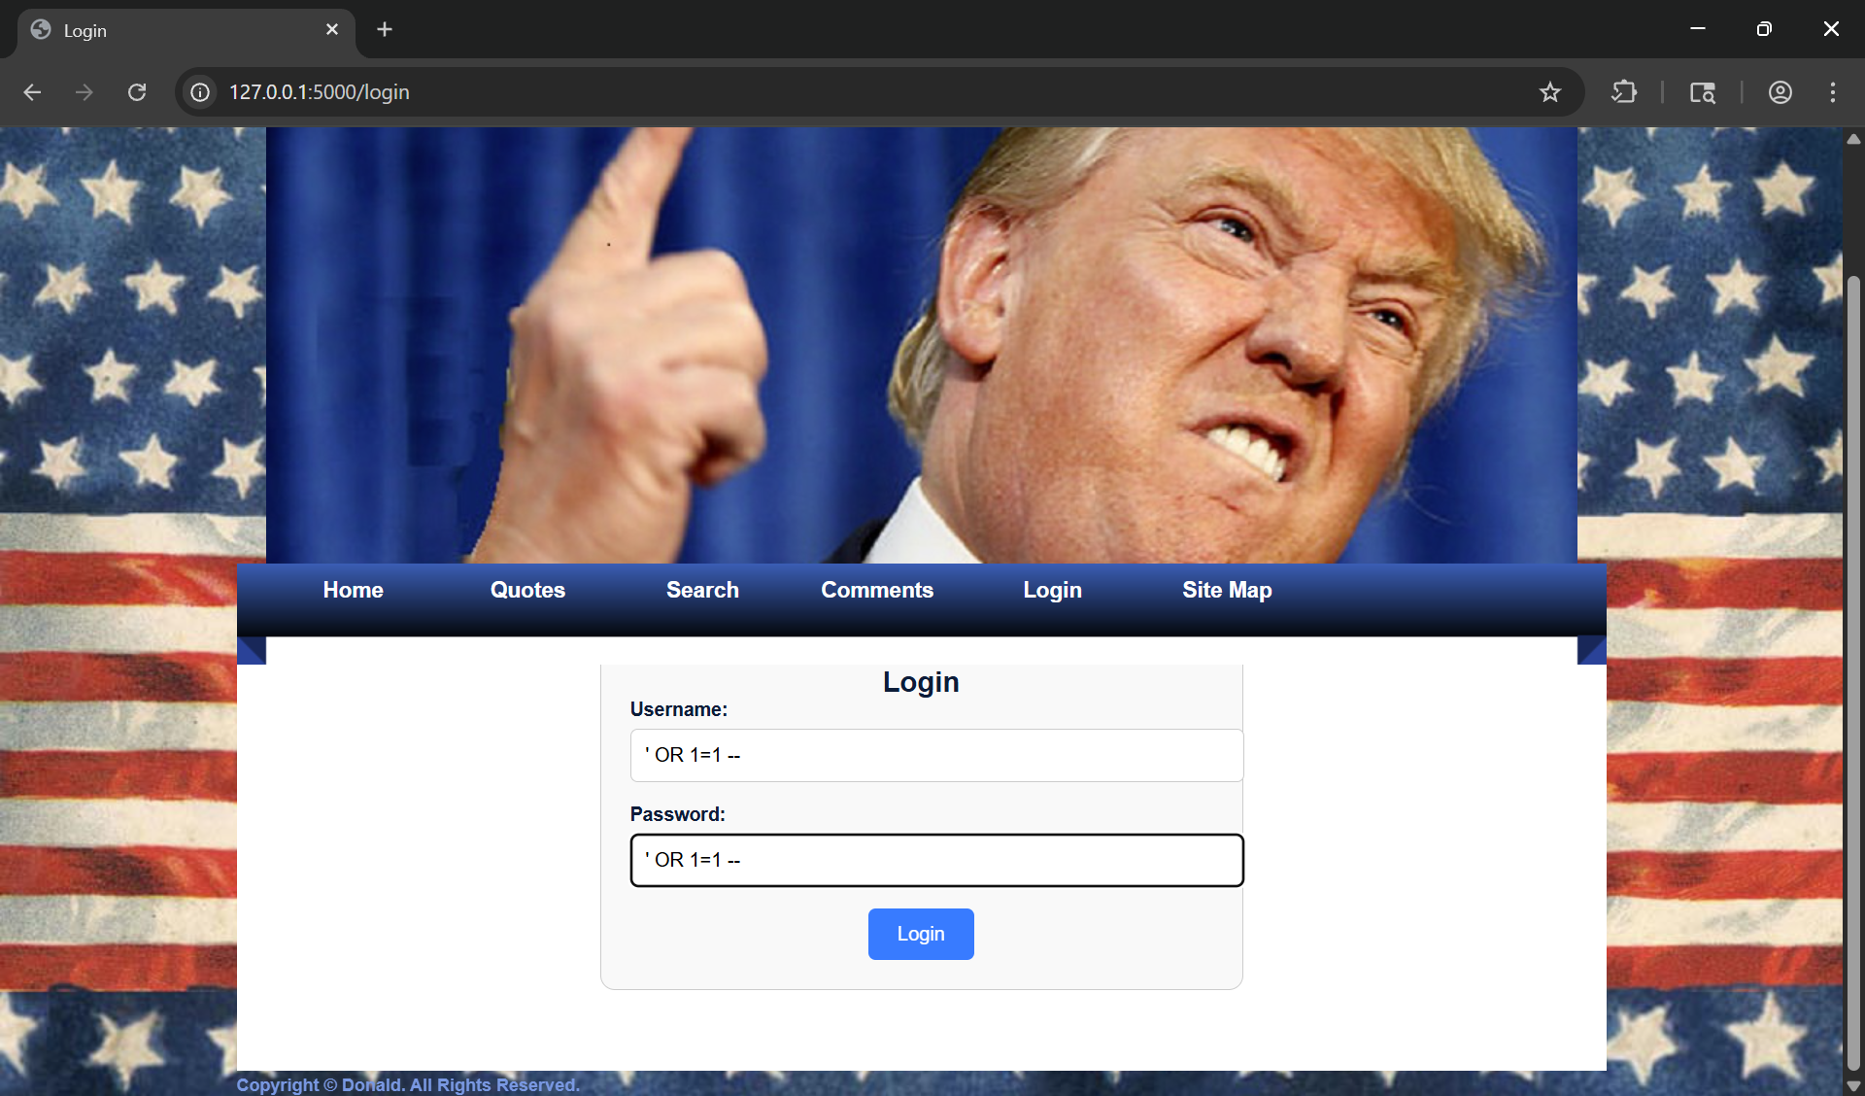

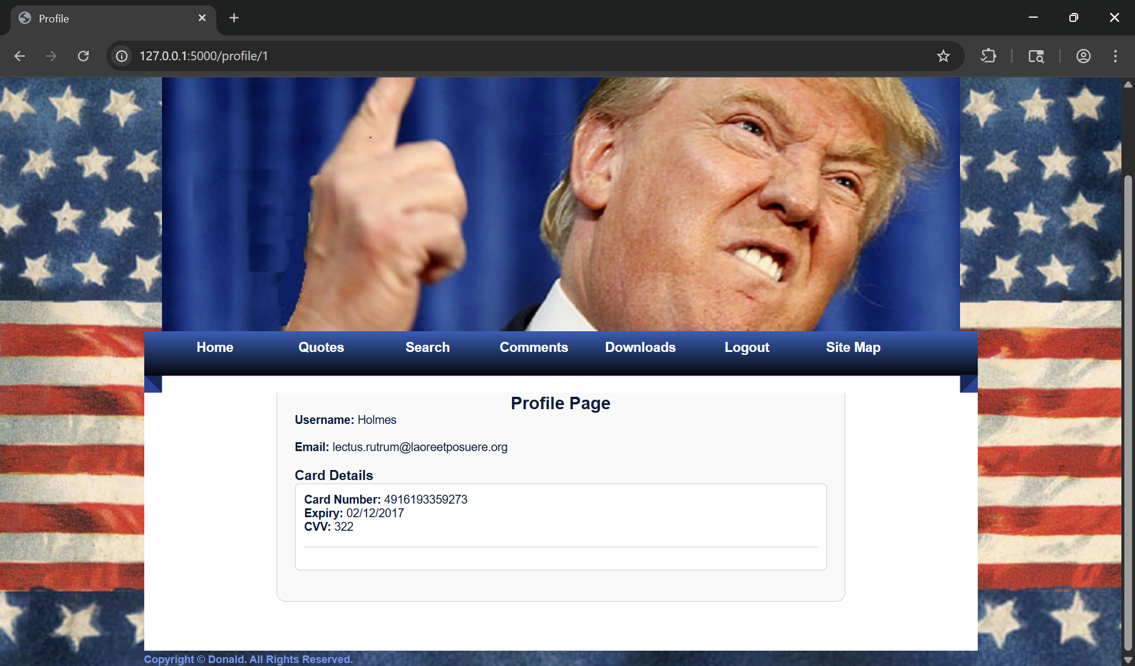

# IDOR

After that I noticed that the Url changed to <http://127.0.0.1:5000/profile/1> so I changed the number and the profile changed to that of another user.

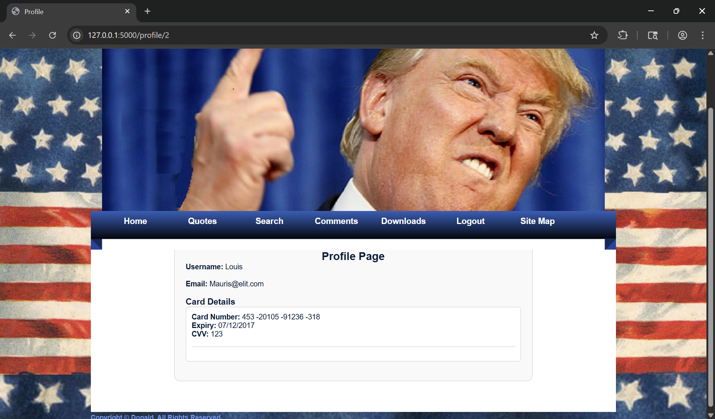

# Stored XSS

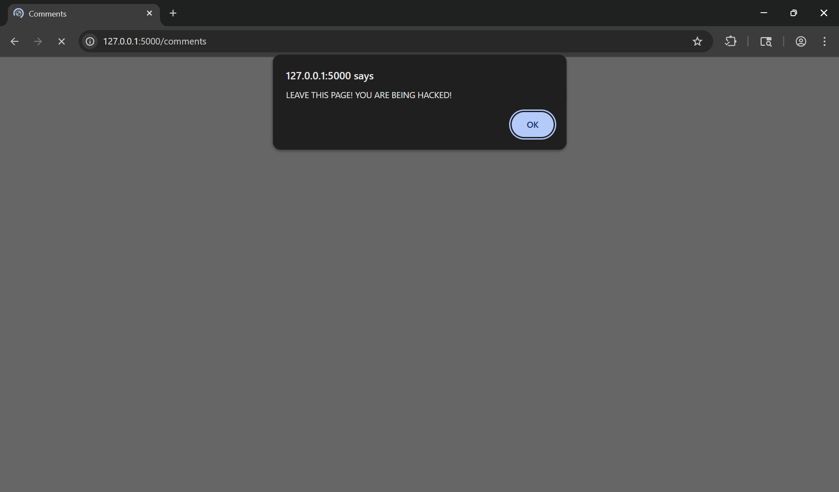

# Credential Leaking

After gaining access to any profile the credit card information of the individual is visible with no hashing or censoring of the sensitive information.



# Shoulder Surfing

The password field in the login page remains so that it’s not hidden. This can allow the user to be prone to shoulder surfing as the password entered is clearly visible.

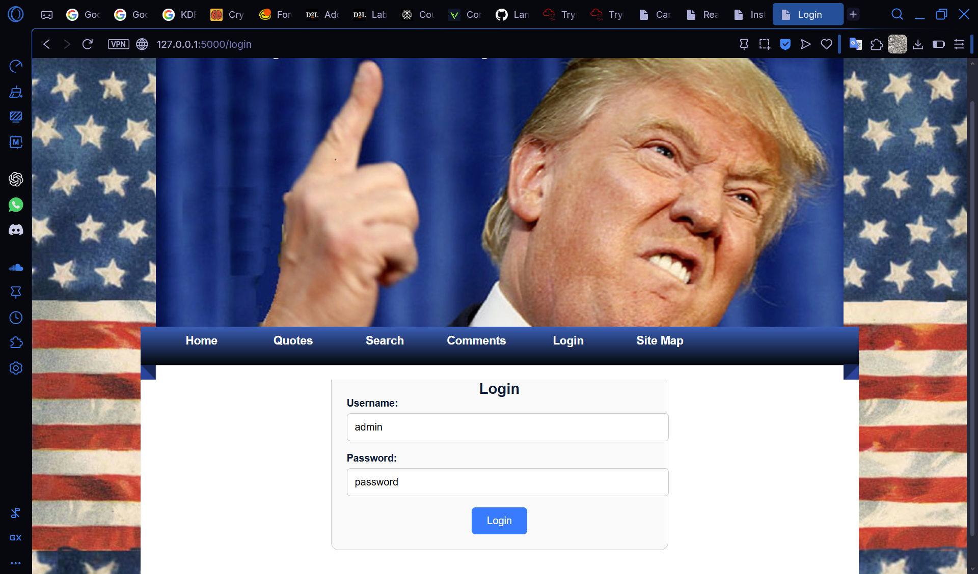

Figure Before Remediation

## Remediation

This is a simple fix in the HTML template used. The original had the password field set to a ‘type’ attribute of ‘text’. When the ‘type’ attribute is changed to ‘password’ the entered text is automatically hidden aiding in shoulder surfing prevention. This was introduced since HTML 2.0.

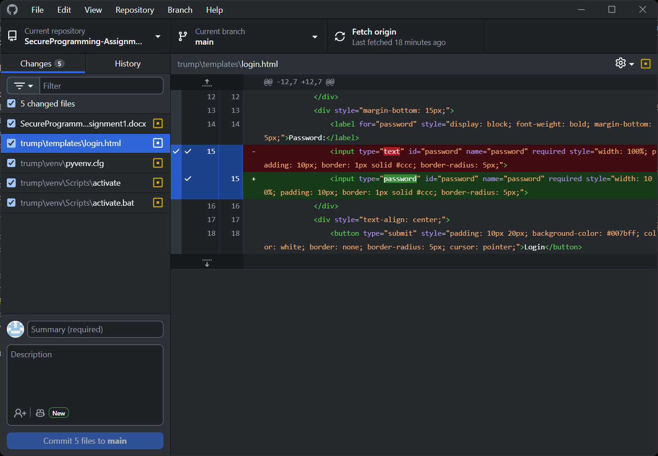

Figure Changes in the source code

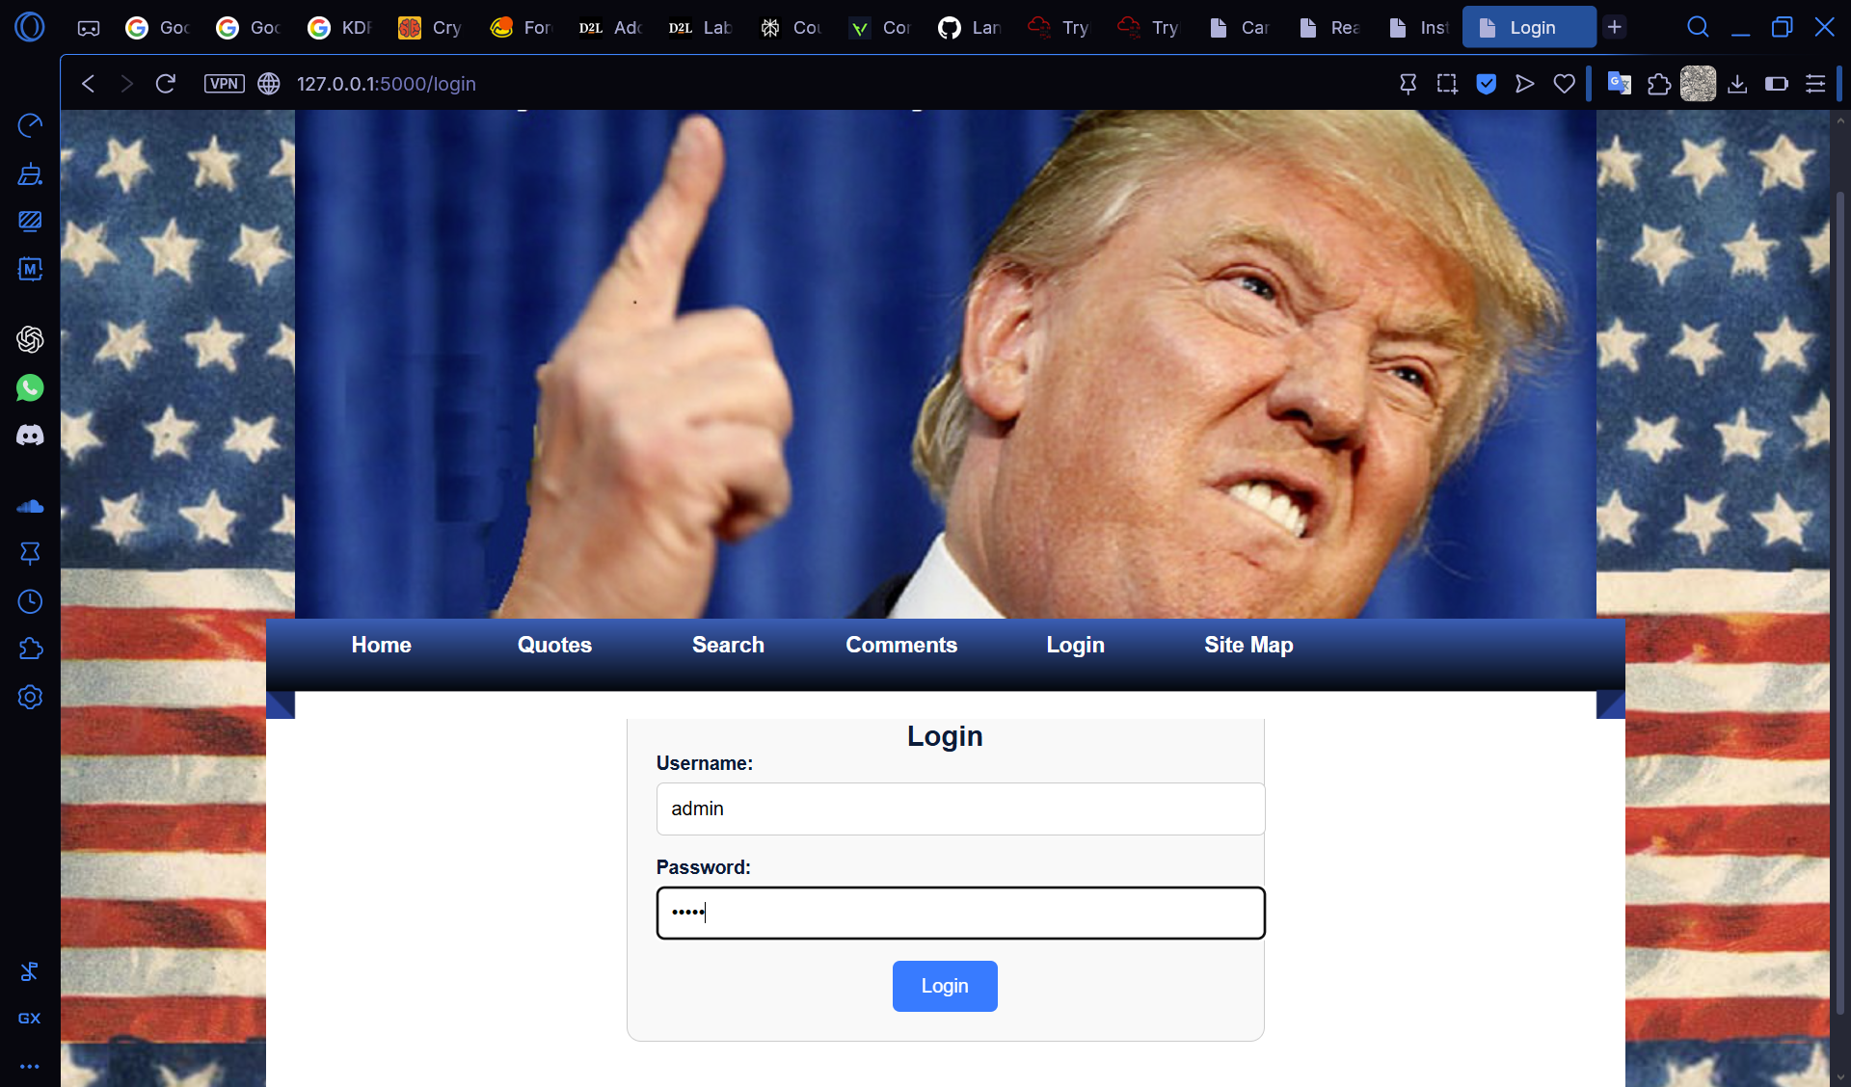

Figure After Remediation

# Resource Exhaustion

The comment section of the website does not have a limiter of any sort. This leaves room for malicious individuals to flood the service potentially leading to a denial of service or rapid performance downgrade. This could be taken advantage of through the use of bots or automated tools.

# Statement of Contribution

## Lan Ngai

## Kai Guy